**Sorting Application:**

The application is used to get Random number from Rest Service and Sort in ascending order by using another Rest Service. This Application also shows the number of position changed to get in ascending order.

This application will also show the previous history of Numbers sorted.

**Prerequisites**

The sorting-app application should be up and Running fine to test the application.

The Rest services should be up and Running fine to test the application.

**GitURL:** <https://github.com/pvimalmec/sorting-app.git>

**Integration Test Results:**

Step1: when the user clicks http://localhost:8080/#/sort.It will be redirected to home page

**Sorting Home Screen:**

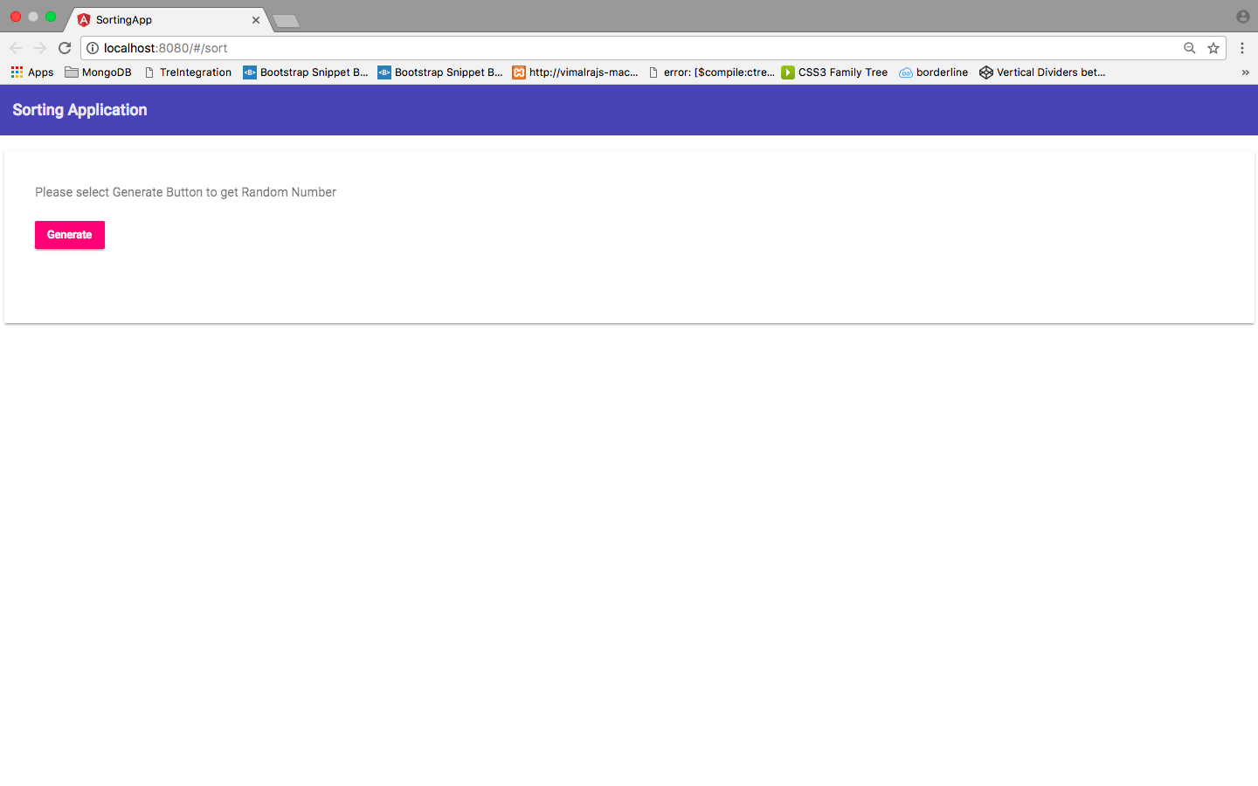

Step2: Please select the Generate button and it will generate 10 random numbers and the Click Sort Now button will be visible.

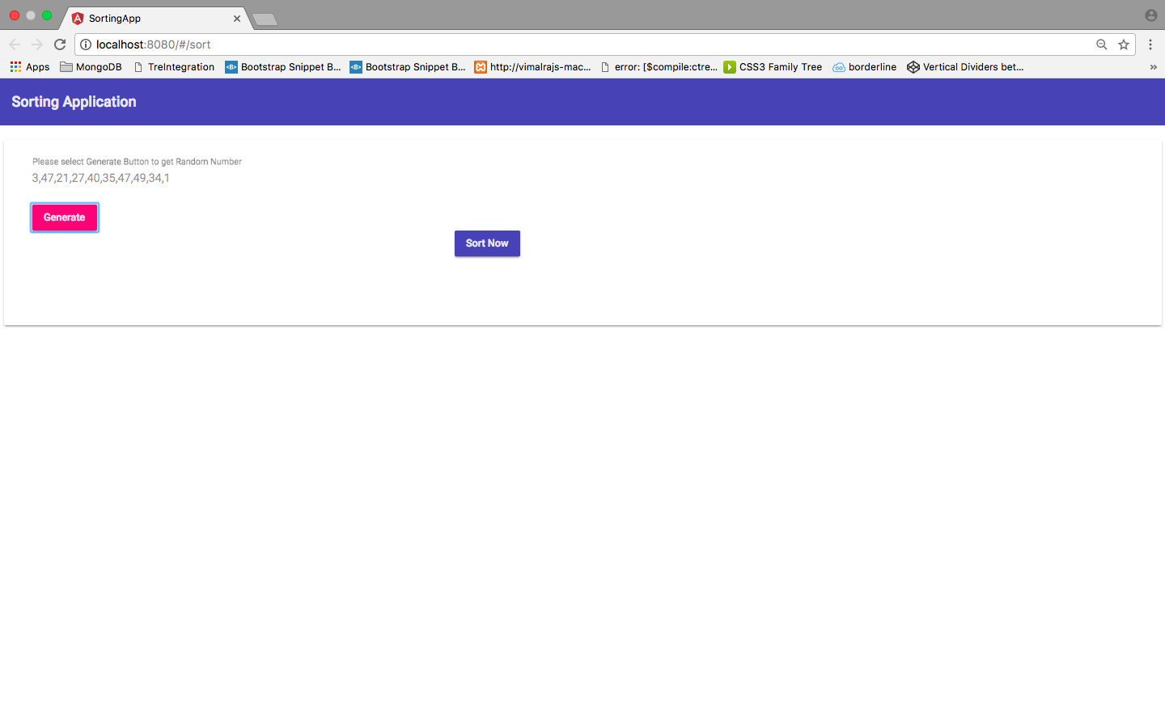Step 3: Please Select Sort Now button, the Sorted numbers in ascending order will be populated.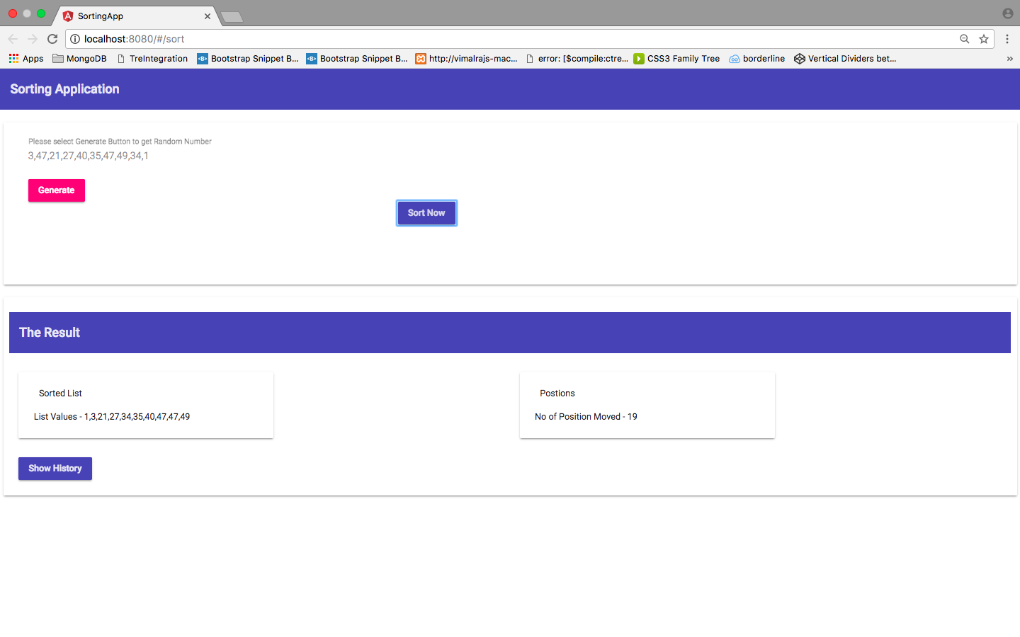

Step 4: To Know the History of Previous Sorted Values. Please Click on the Show History Button.

